
 | 

January news from the Police and Crime Commissioner for Hertfordshire
Dear {FIRST_NAME}
Welcome to my latest newsletter – in this edition:
• Police mergers will be a distraction from the fight against crime
• Improvements in detecting crime scrutinised at my public accountability meeting
• More than 100 arrests across Hertfordshire town centres during winter initiative
• Young artist’s sculpture wins Knife Angel art competition
• Police precept proposal backed by Hertfordshire residents
• And finally… have you seen Hertfordshire’s police officers in action fighting crime and locking up criminals?
If you’re on Facebook, why not follow me and let’s keep the conversation going and if there are any issues you would like to raise, then please email me at commissioner@herts-pcc.gov.uk

Police mergers will be a distraction from the fight against crime


If you’ve seen or read the news over the last week, you couldn’t have avoided the Government’s briefing of the Police Reform White Paper. It proposes a significant overhaul of policing, with greater national control and a weakening of local accountability.

The Home Secretary is proposing that a new National Police Service (NPS) will be set up answering to government. This will contain some national capabilities such as police helicopters and functions relating to counter terrorism and serious organised crime, which is sensible. However, some are concerned about the significant control that one national politician will have over this new organisation.

Under the NPS, it is intended that there will be a small number of regional police forces which will focus on major investigations and co-ordinate ‘local policing areas’ within them. The proposals mean that Hertfordshire Constabulary would cease to exist as a county police force, although a long lead time is expected.

I am concerned about the loss of county police forces, which are generally well connected to their local communities and responsive to local needs. Currently, county police forces tend to perform better than the largest urban forces do.

Bigger does not always mean better. The risk is that resources will be diverted to cities and urban areas in each region, and we end up with an expensive reorganisation that will distract from the fight against crime.

In my recent survey of Hertfordshire residents, huge numbers of you shared my concerns, with just 11% of respondents believing regional mergers would make policing better.
Along with other PCCs, I have had two meetings with the policing minister this week and will ensure that Hertfordshire’s interests are represented in whatever process follows this week’s announcement.
You can read my full comments on the proposals
www.herts-pcc.gov.uk/news/latest-news/2022/police-mergers-will-be-a-distraction-herts-pcc/

Improvements in detecting crime scrutinised at my public accountability meeting
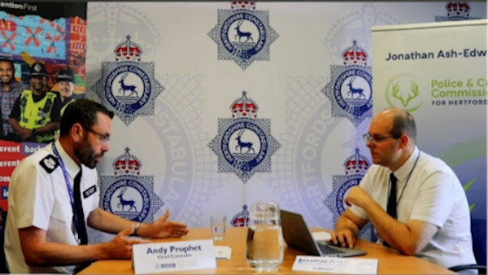

Policing needs to solve more crime both nationally and locally. That’s why I set an objective in my Police and Crime Plan asking Hertfordshire Constabulary to focus on increasing the amount of crime that is being detected in the county. It’s critical to ensure that victims see justice being done and offenders are held to account. Ultimately, more criminals being caught should lower crime for all of us.

This month at my public Accountability and Performance Meeting, I asked the Chief Constable for an update on how Hertfordshire Constabulary was doing. I was pleased to hear that in 2025, Hertfordshire Constabulary solved over 1,300 crimes more than in 2024.
That’s a good start. There’s a lot more to do, but I’m reassured by the significant focus that the Chief Constable is placing on this.
The goal is to move Hertfordshire to be one of the highest performing police forces in the country for crime being solved.
The next public Accountability & Performance Meeting will be held on 12th February and, as ever, will be webcast live to the public.

More than 100 arrests across Hertfordshire town centres during winter initiative
More than 100 suspects have been arrested as part of a countywide initiative to help keep town centres in Hertfordshire safe this winter.
Throughout December and into the new year, Neighbourhood Policing Teams had an increased presence in town centres and retail areas, targeting crime and anti-social behaviour (ASB).
Following the successful Safer Town Centre campaign last summer, tackling retail and street crime, the winter initiative also includes an additional focus on violence against women and girls.
Hertfordshire’s town centres are safe places, but this concerted action is designed to make them even safer and bear down on retail crime, anti-social behaviour and predatory behaviour in the night-time economy. I’ll keep working with the police, councils and businesses on the visibility, proactive action and partnership support to drive down crime in our town centres.

Young artist’s sculpture wins Knife Angel art competition
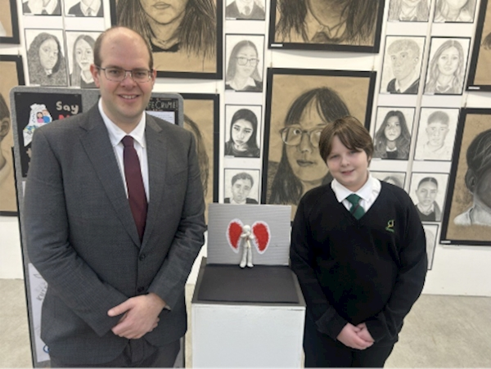

A sculpture with a powerful message took centre stage this month as I visited Chauncy School in Ware to meet Billy, the winner of the Knife Angel art competition and see his striking sculpture up close. It was also great to speak with some of the staff at Chauncy School and hear about the great work they are doing to use art lessons to cover important educational topics.

The Knife Angel art competition invited young people from across Hertfordshire to respond creatively to the Knife Angel sculpture and the message that it carries that violence destroys lives, and prevention starts with education, awareness and opportunity.

Billy’s work is incredibly powerful. He has taken a difficult subject and turned it into something thoughtful, creative and impactful. Seeing the sculpture in real life really brings home just how strong that message is.

What impressed me most is how clearly this competition demonstrates that young people understand the real consequences of knife crime. This isn’t abstract for them. They get it, and they care.

Find out more about my visit to Chauncy School www.herts-pcc.gov.uk/news/latest-news/2022/knife-angel-art-comp-winner/

Police precept proposal backed by Hertfordshire residents

One of my responsibilities as Police and Crime Commissioner is to set the police budget and precept – the part of council tax that we pay towards policing.

Thank you to the huge number of Hertfordshire residents who completed my recent survey sharing your views. There was significant support for my proposal to increase the police precept by £15, with 68% of respondents in agreement.

That increase, if confirmed following scrutiny by the Police and Crime Panel, will help Hertfordshire Constabulary build on the progress being made to answer the phone and get to residents who need help quicker, deliver proactive neighbourhood policing, keep vulnerable people safe and solve more crime.

The increase will still mean that Hertfordshire residents will pay the fifth lowest police precept in England and Wales. It’s about £32 per year below the national average which would raise a sum of money equivalent to about 240 extra police officers.

In my consultation, I asked whether residents would, in principle, be willing to pay more to close that gap only if it went directly into tangible, additional policing and crime fighting. Despite a clear majority, 57%, of residents saying yes and a further 18% being open minded to such a proposal, the Home Office has told me that Hertfordshire won’t be one of the areas to get this flexibility.

And finally… have you seen Hertfordshire’s police officers in action fighting crime and locking up criminals?



As Police and Crime Commissioner, I get to see examples of great policing and crime fighting that the public often don’t hear about. Police officers, backed up by brilliant support staff behind the scenes, arresting drug dealers and car thieves, locking up paedophiles and sexual offenders and getting fly-tippers and dangerous drivers off the road. It happens day in day out.

I’m delighted that the public are now able to see more of this happening. Hertfordshire Constabulary is now regularly publishing more body worn video of these arrests and incidents. If you would like to see more of what your local police officers are doing then have a look at Herts Police on social media platforms such as Instagram and TikTok.

Best wishes,
Jonathan Ash-Edwards
Police & Crime Commissioner for Hertfordshire
 | Message Sent By  Jonathan Ash-Edwards

