
 | 

News from your Commissioner Jonathan Ash-Edwards
February news from the Police and Crime Commissioner for Hertfordshire
Dear {FIRST_NAME}

Welcome to my latest newsletter – in this edition:
• 25,000 hours of high visibility police patrols at risk from Government cancellation of crime hotspot funding
• Live facial recognition technology to be rolled out in Hertfordshire – and see what happened when the PCC was added to the watchlist
• Response times under scrutiny at PCC’s accountability meeting
• Do you know how to report crime anonymously?
• And finally… have you seen Hertfordshire’s police officers in action fighting crime and locking up criminals?

If you’re on Facebook, why not follow me and let’s keep the conversation going and if there are any issues you would like to raise, then please email me at commissioner@herts-pcc.gov.uk
I hope you find this newsletter a useful update on my work on your behalf.

Jonathan Ash-Edwards
Hertfordshire Police & Crime Commissioner

25,000 hours of high visibility police patrols at risk from Government cancellation of crime hotspot funding
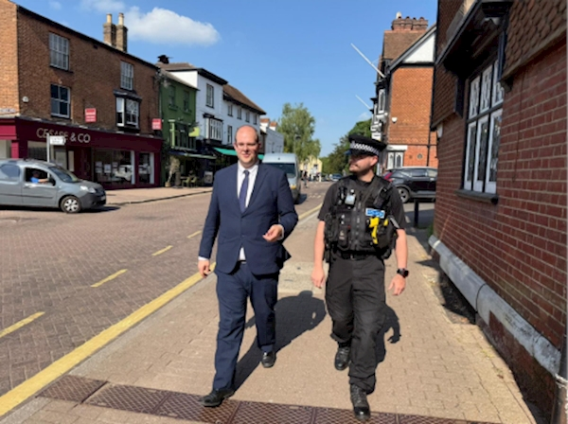

Hertfordshire residents and businesses consistently tell me they want to see more visible police patrols in town centres and crime hotspots. That’s exactly what is being achieved with Operation Hotspot, which I launched shortly after I became Police & Crime Commissioner in 2024.
In 2024/25, Operation Hotspot delivered over 25,000 hours of additional high visibility police patrols, with crime and anti-social behaviour falling by 14.5% in town centres and hotspots, and over 330 arrests during hotspot patrols. The figures for this financial year are even more impressive.

Hotspot policing isn’t rocket science; it’s just common sense. Increasing police patrols in the locations and times when crime is most likely to occur works.

But all of that is now at risk because the funding we have used to fund these additional patrols is being cancelled by the Government on 31st March.
The only people who will welcome the cancellation of these additional patrols will be shoplifters, violent offenders, drug dealers and people committing anti-social behaviour in town centres.

I am working to persuade Government to change its mind. If it won’t, I will work with Hertfordshire Constabulary to do everything that we can to protect as much of the successes of Operation Hotspot as possible.

Read more here

Live facial recognition technology to be rolled out in Hertfordshire
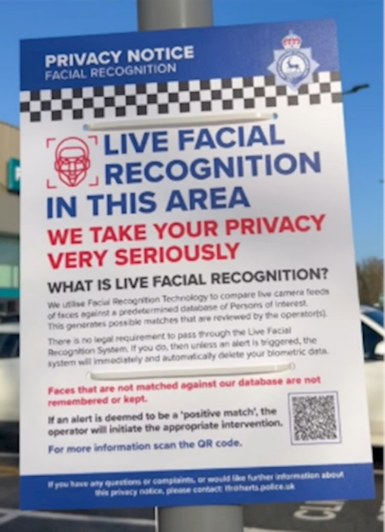
You may recall before Christmas that I let you know that Hertfordshire Constabulary was going to trial Live Facial Recognition (LFR) technology for the first time.

LFR is tried and tested technology that allows the police to use a watchlist of people wanted for serious offences and try and identify them in busy public places.
The technology was tested at the Brookfield Shopping Centre in Cheshunt before Christmas and over 50,000 people who visited the shopping centre were checked against the watchlist. On this occasion, no matches with the watchlist were found and no arrests were made. But importantly, no false positives or bias was identified either.
Hertfordshire residents back the use of this technology – in the public survey I did before Christmas, 81% of the public said the police’s use of the technology was always or usually acceptable. I agree and it has my support as Police & Crime Commissioner.
Following the trial, the Constabulary will be using the technology more regularly across the county.
There are important safeguards in place. Individuals are only on the watchlist if they are wanted for serious offences or if they are subject to monitoring conditions (such as many sex offenders would be). If you are not a match, personal data is deleted immediately and not retained. The decision to engage with a member of the public is made by a police officer, not technology. The Constabulary has deliberately chosen a sensitivity setting in the technology to avoid bias or discrimination.
I scrutinised the outcome of the pilot at my Accountability & Performance Meeting with the Chief Constable this month and will regularly monitor its ongoing use.
If you would like to watch what happens when LFR identifies a match with the watchlist, you can see what happened when I was added to the watchlist and walked past the LFR van here. I promise it was just a test, and I am not on the real watchlist!
And for a more in-depth discussion, you can watch the stakeholder webinar that I hosted this month and hear directly from senior police officers involved in the work. Watch here

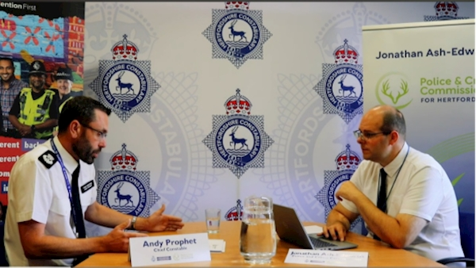
Response times under scrutiny at PCC’s accountability meeting

Having to phone 999 is not an everyday occurrence. But if the worst happens and you need emergency help or a crime is in progress, you need to trust that you will get a quick and effective response from the police.

The Home Secretary recently announced there will be a national target for police forces to attend 999 calls that require an immediate response within 15 minutes in urban areas and 20 minutes in rural areas.

At this month’s Accountability & Performance Meeting with the Chief Constable, I scrutinised how Hertfordshire Constabulary currently performs in this area, ahead of a national target being introduced.

Pleasingly, the Constabulary is already performing very well, with a countywide average of around 10 minutes for officers to arrive at a 999 call which needs an immediate response. I will keep a close eye on this performance to ensure the public continue to get a good service.

I periodically join response teams for a shift to see their frontline work responding to emergencies, keeping people safe and arresting criminals. Their professionalism, courage and resilience in the face of often demanding, unpredictable and sometimes dangerous situations is something we should all be reassured by.

Do you know how to report crime anonymously?

If you need to report a crime, you should have confidence to report it to the police. The 101 non-emergency number is being answered promptly, in around 90 seconds on average, and you can report online or speak to a human in the control room via webchat (no chatbots involved!)
But sometimes, there will be circumstances when people want to report information and stay anonymous.
That’s what Crimestoppers is there for. They are a charity who are completely independent of the police who will take reports of crime anonymously. You do not have to give any identifying information.
This month, I visited their Head Office and contact centre to learn more about the work they do and how we can strengthen the work we already do together in Hertfordshire.
To give information to Crimestoppers, phone free and anonymously on 0800 555111 or report online

And finally… have you seen Hertfordshire’s police officers in action fighting crime and locking up criminals?
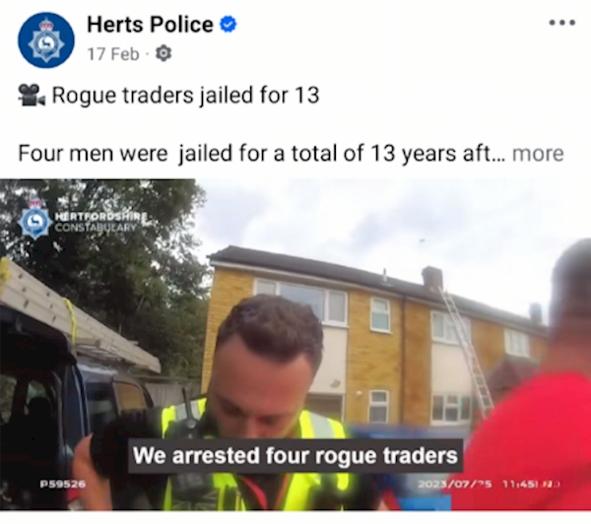

As Police and Crime Commissioner, I get to see examples of great policing and crime fighting that the public often don’t hear about. Police officers, backed up by brilliant support staff behind the scenes, arresting drug dealers and car thieves, locking up paedophiles and sexual offenders and getting fly-tippers and dangerous drivers off the road. It happens day in day out.

I’m delighted that the public are now able to see more of this happening. Hertfordshire Constabulary is now regularly publishing more body worn video of these arrests and incidents. If you would like to see more of what your local police officers are doing, then have a look at Herts Police on social media platforms such as Instagram and TikTok.
 | Message Sent By  Jonathan Ash-Edwards

