
 | 

Your PCC Newsletter for October
News from your Commissioner Jonathan Ash-Edwards
Dear {FIRST_NAME},
Welcome to my newsletter for October 2025 – in this edition:
• Safer town centres positive outcomes
• Hearts for Herts and ‘Restart a Heart’ day
• Fraud, county lines and knife crime under scrutiny
• Electric Umbrella’s anti-hate crime campaign
• Knife Angel Closing Ceremony
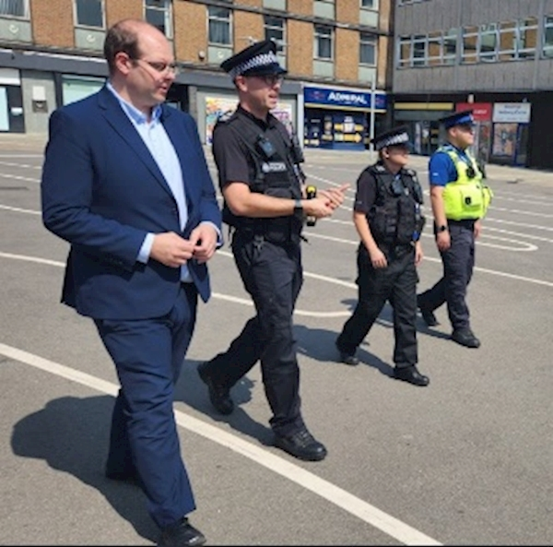
Positive outcomes of the Safer Town Centres summer project
Over the past few months, I have been working with Hertfordshire Constabulary, local councils and Business Improvement Districts on a big push to make our town centres, shopping areas and parks safer.
The work has seen increased police patrols and proactive action to tackle shop theft, anti-social behaviour and robbery. Other agencies have been involved too, such as work with Trading Standards to close dodgy vape shops selling counterfeit or illegal goods and British Transport Police to target shoplifters using the rail network.
I’m pleased to report some positive results – compared with summer 2024, this summer we saw a:
• 6% reduction in overall crime in our town centres
• 28% fall in criminal damage - resulting in 36 fewer victims
• 13% drop in business burglary reports - meaning shops were safer and retail staff less at risk
• 5% increase in possession of drugs offences - there are crimes that must be pro-actively detected by police through patrols and stop searches
I wanted to share a couple of success stories:
• Personal robbery is a high-harm crime often impacting younger people. Watford’s town centre and Cassiobury Park was the largest hotspot in the county last year. As a result of focused work by the Neighbourhood Policing Team as well as initiatives such as having mounted police in the park during the summer, robbery offences in Watford fell by 63% this summer – dozens fewer victims than last year.
• To address increases in retail crime in St Albans last year, significant proactive work has been undertaken with businesses and proactive police patrols. So much so that plain clothes officers recently disrupted a robbery in progress at a phone shop, making two arrests. The tide has been turned on retail crime in St Albans, with 168 fewer offences this summer compared to summer 2024.
There are similar positive stories and proactive work across Hertfordshire’s town centres, and it has been great to see some of it first hand over recent months – from Carpenders Park to Waltham Cross, Borehamwood to Hitchin, Bishop’s Stortford to Tring.
Hertfordshire’s town centres are safe places but this summer’s activity demonstrates that there is always more that can be done to make a difference. The Safer Town Centres project doesn’t end here, however. Operation Hotspot patrols are continuing all year round and work is underway to prepare for more activity in the busy Christmas shopping and party season.

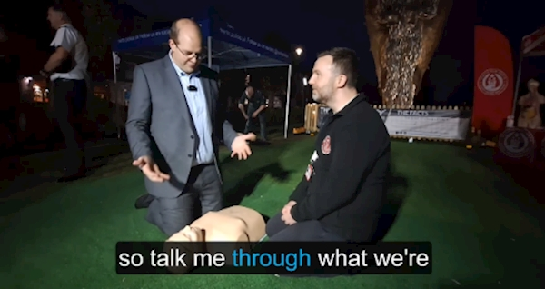
Restart a Heart Day at the Knife Angel
Hearts for Herts is a great local charity providing life-saving equipment and training that could be the difference between life and death for someone in cardiac arrest.
They run a free ‘Lifesaver’ course – which I’d highly recommend signing up for here.
They also provide life-saving equipment, including ‘Bleed Kits’ – of which I am pleased to have funded 60 with my commissioning budget. Placed in the same cabinets as publicly accessible defibrillator cabinets, Bleed Kits contain supplies which could save the life of someone experiencing extreme bleeding.
16th October was national ‘Restart a Heart Day’, and I spent time with the Hearts for Herts team at the Knife Angel site in Welwyn Garden City. They were there to provide refresher CPR courses to the public – the first time this has ever happened alongside the Knife Angel.
Take a moment to refresh yourself about how to perform CPR with my video here – it could save a life!

Fraud, county lines and knife crime under scrutiny
Each month, I webcast my Accountability & Performance Meeting with the Chief Constable so Hertfordshire residents can see how I’m scrutinising the work and performance of Hertfordshire Constabulary.
As well as being available live, the previous recordings can be watched on my website and this month’s is now available.
I used this month’s APM to look at the work the Constabulary is doing on fraud, county lines, knife crime and serious violence – watch the conversation back here.
Previous recordings can be found on my website here.

Electric Umbrella’s “It’s Not a Crime to be Different” campaign

Electric Umbrella is a Herts based charity which empowers learning disabled and neurodivergent people through music and collaboration. You may remember them from Britain’s Got Talent – where they famously earned Simon Cowell’s ‘Golden Buzzer’.
This month, Electric Umbrella and Hertfordshire Constabulary teamed up to create a light-hearted song and music video called ‘It’s Not a Crime to be Different’. It does carry a serious message that targeting someone because of a disability – or other protected characteristics – is treated by the criminal justice system as an aggravating factor in crime.
I was pleased to visit Electric Umbrella to find out more about their work in Hertfordshire and take part in a documentary they made to highlight the campaign – find a link to the documentary here
Meanwhile, you can read more about Electric Umbrella's campaign here

Knife Angel Closing Ceremony
The Knife Angel has been in Welwyn Garden City over the course of October. It’s stimulated some important conversations about knife crime across the county.
If you haven’t already been to see it, you still can – the Knife Angel Closing Ceremony takes place on Thursday 30th Oct from 5.30pm in Welwyn Garden City town centre.
There’ll be a musical performance by inclusivity program Everybody Loves Music, as well as a motivational talk led by spoken-word artist and anti-knife crime campaigner Quinton Green.
I’m grateful to Welwyn Hatfield Borough Council and the Constabulary for collaborating to get the Knife Angel to our county for the first time. The closing ceremony will be a poignant occasion, and I’d recommend coming along.
You can read more about what’s in store at the closing ceremony on the constabulary’s website here.
The closing date for my Knife Angel art competition is November 7th, so there’s still plenty of time to get any young people you know involved. You can get an application form and read more here.
That’s all for now - keep an eye out for news updates on my website here and feel free to email commissioner@herts-pcc.gov.uk with your thoughts.
Best wishes
Jonathan

Jonathan Ash-Edwards
Police and Crime Commissioner for Hertfordshire
 | Message Sent By  Jonathan Ash-Edwards

