
 | 

Your PCC Newsletter for November
November news from the Police and Crime Commissioner for Hertfordshire
Dear {FIRST_NAME},
Welcome to my newsletter for November 2025 – in this edition:
• More police patrols in your town centre this winter
• More crime being solved and your calls to police answered quicker
• Cracking down on dangerous drivers
• Voting opens on Monday for the Knife Angel art competition
• Reaffirming my commitment to Hertfordshire residents with an 18% cut in the size of the PCC’s office
If you’re on Facebook, why not follow me and let’s keep the conversation going.

More police patrols in your town centre this winter
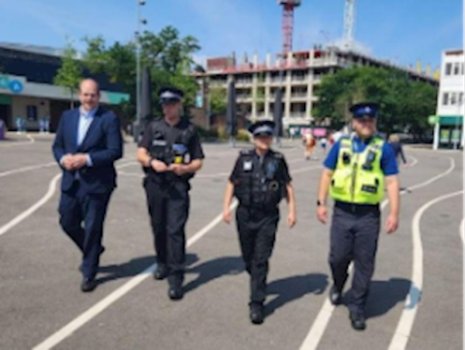
During the Christmas and New Year season, our town centres come to life as we turn our attention to shopping, parties or just seeing the Christmas light displays.
I want people to be able to make the most of Hertfordshire’s town centres safely this winter.
So, over the coming weeks, there will be concerted work to bolster police presence in our town centres and retail parks as part of our Safer Town Centres initiative. It will have a focus on shoplifting, anti-social behaviour and ensuring the night-time economy is safe by tackling things like violent disorder, predatory behaviour and spiking.
Similar work during the summer made a real difference – cutting town centre crime by 6% during the summer months compared to last year. Thank you if you took part in my surveys; your feedback has been key to shaping the next steps of this project.
At the heart of our Safer Town Centres work is Operation Hotspot, the initiative I launched last year to put more high visibility police patrols into crime and anti-social behaviour hotspots.
I recently reviewed the progress with Operation Hotspot during the first half of this financial year – and the results are impressive. From April to September, patrol hours, arrests, stop searches and weapons seizures are all up on the same period last year.
In the first six months of this financial year, over 16,000 hours of additional police patrols were carried out, with officers making 225 arrests, carrying out 393 stop searches, seizing 46 knives and making 979 uses of anti-social behaviour powers.

More crime being solved and your calls to police answered quicker

Improving the policing we get in Hertfordshire is a key priority in my Police & Crime Plan. I'm pleased to be able to update you on some positive progress by Hertfordshire Constabulary to improve how it serves our communities.
More crime is being solved.
In the first 10 months of 2025, over 1,200 more crimes were solved than the first 10 months of 2024. This means more criminals facing consequences, more victims seeing justice being done and, often, further offending being prevented. There is much more to be done, but some welcome signs of progress being made.
Your calls to the police are being answered quicker.
Most of us won’t have to phone the police often. But the police are there 24/7 if people need help or need to report a crime. It matters that the phone is answered quickly, especially when people are at risk. Significant improvements have been made to call answering times, with Hertfordshire meeting the national 999 call handling target in September and October – the first time in over four years where it has been met in those months.
If you need to phone 999 in an emergency, your call will be answered in an average of around 5 seconds. If you phone the 101 non-emergency number, your call will be answered in an average of 42 seconds (September data). There are few public services answering the phone as quickly.
Getting these things right really matters; my thanks to all the police officers and staff working tirelessly to deliver for our county.

Cracking down on dangerous drivers
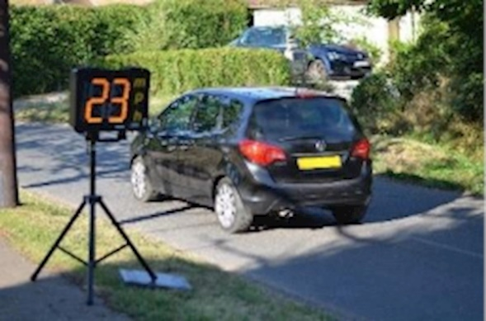
Road Safety Week was during November and it’s a timely reminder that every time we get behind the wheel, the choices we make can save lives.
Earlier this year, the Hertfordshire Constabulary stepped up enforcement work to tackle the ‘Fatal Five’ driving behaviours that cause the most collisions: speeding, drink or drug driving, careless driving, not wearing a seatbelt, and using a mobile phone behind the wheel.
These actions put every road user in the county at real risk.
Thanks to this targeted work, officers achieved the following results:
• 193 arrests for drink or drug driving — the highest across the region
• 32 careless driving offences
• 93 seatbelt offences
• Speeding: 150 offences recorded by the Roads Policing Unit
Every one of these interventions represents a potential tragedy prevented, a family spared from life-changing news, a child still able to walk home from school and a loved one returning home at the end of the day. Keeping Hertfordshire’s roads safe is something we all play a part in.

Voting opens on Monday for the Knife Angel art competition
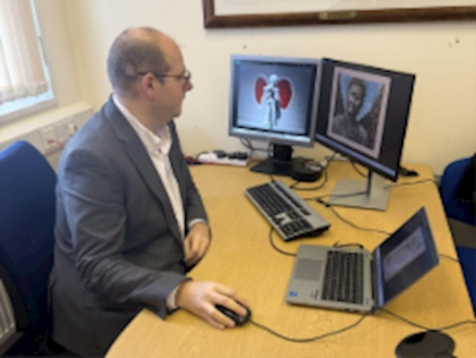
Young people across Hertfordshire have created powerful artwork exploring the impact of Knife Crime, as a legacy from the Knife Angel’s visit to Welwyn Garden City in October.
From Monday afternoon, you’ll be able to vote for your favourite entry on my website, and the winner will be displayed in Hertfordshire for all to see.
I was bowled over by the standard of the submissions. The creative way young people expressed their feelings to knife crime and the Knife Angel were really impressive.
So, do take a few minutes on Monday to take a look for yourself and cast your vote by visiting www.herts-pcc.gov.uk.

Reaffirming my commitment to Hertfordshire residents with an 18% cut in the size of the PCC’s office

While politicians normally expand their offices, I’ve done the opposite by cutting mine by 18%. A restructure has been carried out over recent months to streamline my office’s work and focus on delivering the Police & Crime Plan priorities.
It will save over £300,000 that will be reinvested into community safety projects and improvements in policing locally.
Since my election, I’ve been modernising how the role of PCC works, with a firm focus on the public’s priorities. Taxpayers believe that public service should always provide value for money, and I agree. My priority is to make every pound count for the people of Hertfordshire and freeing up more money for policing and community safety is the right thing to do.
You may have seen the Government’s Announcement that Police & Crime Commissioners will be abolished in 2028. This announcement was not unexpected. It was already government policy to replace PCCs with directly elected mayors who will have responsibility for policing and crime. Hertfordshire’s leaders had already written to the government requesting a mayor for the county in 2028. This announcement just means that policing and crime will need to be at the heart of the mayor’s role.
I’m still fully committed to serving Hertfordshire for the whole of my term and I continue to work hard to deliver meaningful improvements.
There are, however, still answered questions about the government’s intentions for wider police reform. I am concerned that the weakening of local accountability is deliberate and signals a centralised approach to policing that could shift focus away from the priorities of Hertfordshire’s communities. It’s vital that local democratic oversight is protected so policing remains responsive to the people it serves.
That’s all for now - keep an eye out for news updates on my website here and feel free to email commissioner@herts-pcc.gov.uk with your thoughts.

Best wishes,
Jonathan

Jonathan Ash-Edwards
Police and Crime Commissioner for Hertfordshire
P.S. Don’t forget to follow me on Facebook to keep up with the latest news as it happens.
 | Message Sent By  Jonathan Ash-Edwards

