

Decision by the Police and Crime Commissioner for Hertfordshire

Item: SARC Variation Agreement
Date: 6th July 2025
Background: Variation to the Sexual Assault Referral Services for Beds, Cambs, Herts, Norfolk, Suffolk and Essex
Paper: SARC Variation Agreement
Decision: Agreed by PCC

Contract Variation Form No: 01

Contractor: Mountain Healthcare Ltd | Contract No: 7F-2022-C108
Contract Title: Sexual Assault Referral Services  - Beds, Cambs, Herts, Norfolk, Suffolk & Essex | Original Contract Period:  01/04/2024 – 31/03/2028 with possible 3 x 12 months extension.
It is hereby agreed that the following Variation to Contract No 7F-2022-C108 (Sexual Assault Referral Services - Beds, Cambs, Herts, Norfolk, Suffolk & Essex) shall be implemented in line with Clause 6.1 and 6.2 of the Contract Terms and Conditions and shall take effect from 1 June 2025.

Variations to Terms & Conditions
The NHSE is committed and has accepted to fund 1 SARC that is open 24/7 in addition to the current provision, including the following:
Commercial Agreements
Location for overnight service | - Cambridge.
Location for additional acute  paediatric clinic on a Sunday | - Rotates each week between Cambridge, Essex, and Herts.
Length of Mobilisation Period | - 8 months from the date of signing the contract variation (please see note below)
Cost for extending the service | - £856,764 per annum
Cost for Mobilisation | - £84,796 (one off cost)
Cost of HEP B Vaccinations | - Adults = Indicative cost of £142.91 (Pack of 10)  - Paeds = Indicative cost of £10.64 (Single Pack).  - These will be paid on receipt evidence of utilisation rather than included as a block  - For each order placed there is currently a £30 delivery by the supplier, which includes ensuring temperature control during delivery.  - The price of HEP B vaccinations may vary over time and only the cost incurred will be recharged.
Activities / Items Funded by Mountain Healthcare at no additional cost | - The purchase of 6 x Drugs Fridges / 6 x Remote Thermometers / 6 x Anaphylaxis Kits.  - Training the staff to administer the first dose of the HEP B vaccination if clinically indicated and within 1 week of incident (further doses will need to be through the GP).  - Undertaking the first dose of the vaccination on an going basis.
Purchase Order separate from the main Contract will be issued to Mountain Healthcare.
All remaining existing Terms and Conditions of Contract No 7F-2022-C108 will remain unchanged unless otherwise notified in writing.

APPENDIX

FORM OF ORDER

RELEVANT AUTHORITY ORDER
Sexual Assault Referral Service
    Order No: | Beds -  Cambs – AGN2324 Herts – HAN38696  Suffolk – 8043187  Norfolk - 6083459 Essex -
Relevant Authority on the Agreement | The Police and Crime Commissioner for Bedfordshire and the Bedfordshire Chief Constable, Police HQ, Woburn Road, Kempston, Milton Keynes, Bedfordshire MK43 9AX ("Bedfordshire Police")  The Police and Crime Commissioner for Cambridgeshire and the Cambridgeshire Chief Constable, Hinchingbrooke Park, Huntingdon, Cambridgeshire PE29 6NP ("Cambridgeshire Police")  The Police, Fire and Crime Commissioner for Essex and the Essex Chief Constable, Kelvedon Park, London Road, Rivenhall, Witham, Essex CM8 3HB (“Essex Police”)  The Police and Crime Commissioner for Hertfordshire and the Hertfordshire Chief Constable, Harpenden Police Station, 13 Vaughan Road, Harpenden, Hertfordshire AL5 4GZ ("Hertfordshire Police")

The Police and Crime Commissioner for Norfolk and the Norfolk Chief Constable, Building 8, Jubilee House, Falconers Chase, Wymondham, Norfolk NR18 0WW ("Norfolk Police")
The Police and Crime Commissioner for Suffolk and the Suffolk Chief Constable, Police HQ, Portal Avenue, Martlesham Heath, Ipswich IP5 3QS ("Suffolk Police")
Commencement Date: | 1 June 2025
Effective Date | The latter of the dates that the Supplier and the Authority signs this Agreement.
Services: |   SARC Specification - New Award.pdf  Finance.admin@cambs.police.uk Finance.admin@herts.police.uk Payments@suffolk.police.uk accounts@norfolk.police.uk  business.services.essex@ecis.police.uk
Other minor Contract Variations: | Purchase order separate from the current contract to be raised.
Invoicing requirements and e-mail address for submission | Invoicing – Monthly in arrears to each Force  For information on service credits, please see Section B Schedule 3 (Pricing Schedule) Part B of the existing Contract.  Finance Team Email: finance.admin@beds.police.uk Finance.admin@cambs.police.uk Finance.admin@herts.police.uk Payments@suffolk.police.uk accounts@norfolk.police.uk  business.services.essex@ecis.police.uk



OFFICIAL

Reports required by the Relevant Authority: | Management Information (MI)  The collation of comprehensive, up-to-date and accurate management data is crucial to effectively implement the Authority’s organisational policies and strategies. The Supplier will be required to provide the following information on a monthly basis in the format agreed with by the Contract Manager:  - A progress report against the plan for obtaining ISO15189 accreditation plus reporting on maintenance and any risks to the ISO15189 accreditation throughout the Contract Period;  - All records relating to the Supplier’s compliance with the Forensic Science Providers’ Codes of Practice and Conduct;  - All records consistent with Good Industry Practice;  - All operation and maintenance manuals prepared by the Supplier for the purpose of maintaining the provision of the Services and any underlying IT environment, cyber security and Supplier equipment including (but not limited to) the Quality Management System documentation.  - Monthly reports detailing the Suppliers actual performance against the services set out in Schedule 1 (Specification) and the Performance Indicators and any incurred Service Credits;  - Quarterly audits and reports against Performance Indicators.  The Contract Manager may request additional information to assess the performance of the deliverables against the organisational goals and objectives. The Supplier shall provide the Contract Manager with such reports of the services, goods or copies of the deliverables at such intervals and in such form as the Authority may from time to time reasonably require.  Key Performance Indicators (KPIs)  The Service levels and KPI are set out in Schedule 4 (Service Levels).

Price: | FMT and Mobilisation Cost for CV v10.pdf  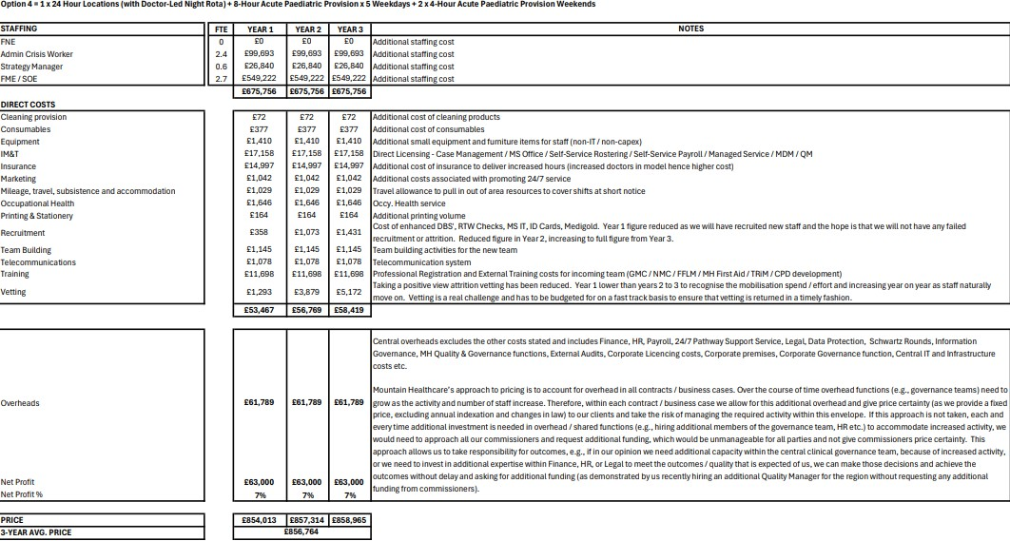
Relevant Authority Representative: | Kevin Baldwin - Temporary Assistant Chief Constable (for Essex)  Julie Dean – Temporary Assistant Chief Constable (for Norfolk & Suffolk) Ian Simmons – Detective Chief Superintendent (for Bedfordshire, Cambridgeshire & Hertfordshire)
 | Toyosi Ogunyemi
 | Supplier Relationship Manager
 | Toyosi.Ogunyemi@kent.police.uk
 | Simon Fenning
 | Head of Strategic Commercial Solutions
 | Simon.Fenning@herts.police.uk
Notices | Mr David Levy
 | David.Levy@essex.police.uk
 | 7 Force Director of Commercial Services
Supplier Representative: | Rebecca Summerfield  SARC Regional Contract Director, East

Execution | Signed for and on behalf of  (The Police and Crime Commissioner for Bedfordshire)  Signature:  Name (block capitals):  Position: Police and Crime Commissioner  Signed for and on behalf of  (The Police and Crime Commissioner for Cambridgeshire)  Signature:  Name (block capitals):  Position: Police and Crime Commissioner  Signed for and on behalf of  (The Police and Crime Commissioner for Essex)  Signature:  Name (block capitals):  Position: Police and Crime Commissioner  Signed for and on behalf of  (The Police and Crime Commissioner for Herts)  Signature:  Name (block capitals):  Position: Police and Crime Commissioner  Signed for and on behalf of  (The Police and Crime Commissioner for Norfolk)  Signature:  Name (block capitals):  Position: Police and Crime Commissioner Signed for and on behalf of  (The Police and Crime Commissioner for Suffolk)  Signature:

Name (block capitals):
Position: Police and Crime Commissioner

Signed for and on behalf of
The Supplier by a Director
Signature:
Name (block capitals): Position:

D Preston
D Preston (Jun 16, 2025 08:42 GMT+1)
Signature:

Email:

Signature:
Email:
darryl.preston@cambs.police.uk

John Tizard
John Tizard (Jun 16, 2025 11:36 GMT+1)
john.tizard@beds.police.uk

Jonathan Ash-Edwards
Signature:
Jonathan Ash-Edwards (Jul 6, 2025 15:52 GMT+1)

Email:
OFFICIAL
jonathan.ash-edwards@herts-pcc.gov.uk

7F-2022-C108-SARS Variation 001 22052025
Created:
2025-07-02
By: Status:
Transaction ID:
Busola Shotunde (olubusola.shotunde@kent.police.uk) Signed
CBJCHBCAABAAzDelLoC9QQ-8Cn4vnFewx6OUE1tNJwx9
Final Audit Report 2025-07-06

"7F-2022-C108-SARS Variation 001 22052025" History
Document created by Busola Shotunde (olubusola.shotunde@kent.police.uk)
2025-07-02 - 1:32:51 PM GMT- IP address: 194.72.142.34

Document emailed to jonathan.ash-edwards@herts-pcc.gov.uk for signature
2025-07-02 - 1:34:48 PM GMT

Email viewed by jonathan.ash-edwards@herts-pcc.gov.uk
2025-07-06 - 2:50:44 PM GMT- IP address: 165.225.80.134

Signer jonathan.ash-edwards@herts-pcc.gov.uk entered name at signing as Jonathan Ash-Edwards
2025-07-06 - 2:52:00 PM GMT- IP address: 165.225.80.134

Document e-signed by Jonathan Ash-Edwards (jonathan.ash-edwards@herts-pcc.gov.uk)
Signature Date: 2025-07-06 - 2:52:02 PM GMT - Time Source: server- IP address: 165.225.80.134

Agreement completed.
2025-07-06 - 2:52:02 PM GMT



