Hertfordshire Community Stop and Search Panel
Thursday 29th January, 5.30pm-8.30pm
Titan Court
Minutes
Attendance:
Demitrius Nurse (Chair)  Andy Taylor  Jerry Rudd  Jacqueline Gaffin  Eddie McCarroll  Linda Blake  John Gillett  Nigel Marshall  Paulette Reed |  | DN  AT  JR  JG  EMc  LB  JG  NM  PR | Dennis Elam  Ben Platt  Tara Bullworthy  Insp. Clare Cray  Ch/Insp Dave Cooke  Sg. Helen Wise  Charlotte Rainer  Amie Birkhamshaw  Eleanor Makoni | DE  BP  TB  CC  DC  HW  CR  AB  EM
Also present: Harvey Marshall, PC George, and Chris Pratt.

1 | Welcome, Introductions and Apologies
1.1 | The Chair (DN) welcomed panel members, officers from the Constabulary and observers, particularly Donna Amhari-Smith (observer) and Harvey Marshall (under 18 observer) who expressed interested in the scrutiny process in support of his studies.
1.2 | Apologies were noted from: Jeffrey Burke, Bukola Enfushile, Phil Millard, Jamal Pasha, Mohammad Islam-Ruman, Valerie Shrimplin, Godrey Minsky, Robert Lloyd and Mamadou Bah.
1.3 | DN advised the panel that David Reynolds has retired from the Stop & Search Panel. He asked for thanks to be formally recorded in the minutes, alongside recognition of David’s contribution to the panel.  DN also noted that Sue McNeill left her role at the OPCC in December. DN recognised Sue’s work and asked for thanks to be extended to Sue and formally recorded in the minutes.
2 | Minutes of the Previous Meeting, Actions and Matters Arising.
2.1 | The minutes of the previous meeting held in November 2025 were agreed and the action tracker was updated.
2.2 | The previous referred cases to the Use of Force panel had been reviewed and graded Green 1. No further issues were raised.
3 | Data presentation from Police Powers Board
3.1 | CP presented a detailed walk through of Stop and Search data, including a demonstration of the Power BI dashboard with analytics, filtering and trend exploration. CP noted that dashboard access is limited only to police email accounts. Data on the dashboard includes:  - Stop and search volumes, showing long-term decline with regular seasonal peaks in the Summer and October  - Reasons for search – drugs account for approx. 55% of all searches  - Disproportionality trends, particularly higher rates for Black individuals  - Self-defined ethnicity, this is missing in approx. 20% of all cases  - Positive outcome rates - variations across districts and individual officers.  A copy of CP’s slides will be circulated with the minutes.
3.2 | EMc asked a question regarding disproportionality data surrounding ethnicity, age and gender, and if it would be worthwhile doing further deep dives on this, for example, ethnicity and outcome rate, and CSP comparisons. The importance of data leading to actual improvements and not just repeated reporting was noted.
3.3 | Concerns were also expressed that the data sub-group has lost momentum. AB suggested that CP’s slides from the Police Powers Board are shared with the panel, which then can be used to inform deep dives and conversations on data.
4 | Chair and OPCC updates
4.1 | DN provided an update from the Police Powers Board. There was a request from the board for the panel to scrutinise Section 32 searches (search after arrest). Whilst the panel agreed in principle, additional training was requested before the remit of the panel could be expanded.
4.2 | AB provided an update on behalf of the OPCC. The office has undergone an 18% reduction in staffing, impacting capacity. The PCC’s priorities have also changed following the publication of the new Police and Crime Plan. This means we need to look at how we best organise ourselves as an office, including how we conduct police scrutiny.  Consequently, the OPCC is exploring differing operating models for scrutiny panels. Options include quarterly meetings and combining Stop & Search and Use of Force panel to create an omnicompetent panel. Conversations will be conducted with the Chairs of both panels over the coming weeks on the future format of scrutiny panels, before consulting more widely with panel members.  Concerns were raised again by panel members regarding the low public awareness of scrutiny panels (a consistent concern raised by panel members), the lack of engagement with young people and diverse community groups, and the need to increase sampling to review more records.
5 | Constabulary feedback
5.1 | CC presented feedback on cases previously graded as serious concern. Feedback included:  - Body worn video missing: DN asked what the stance is on BWV not being recorded. CC stated that sometimes there are issues with batteries, a malfunction with the camera, or officers may forget to switch it on. If BWV is repeatedly not being recorded by an officer, then the Constabulary will review this to understand the reasons. Clearer explanations were requested when BWV is missing.  - Record completion: One case had been graded red where an officer completed another’s search record, which was deemed not acceptable. Supervisors have provided training and wider team learning will be carried out.
6 | Panel Feedback – Countywide
6.1 | The scrutiny took place between 18:30 and 20:15.  The OPCC is currently trialling the use of tablet devices to digitise the feedback process. The dashboard that follows illustrates how feedback will be presented under the new digital approach, including the gradings as recorded by the panel.
6.2 | As there were insufficient panel members for five subgroups, group four and group five records were not scrutinised.
6.3 | 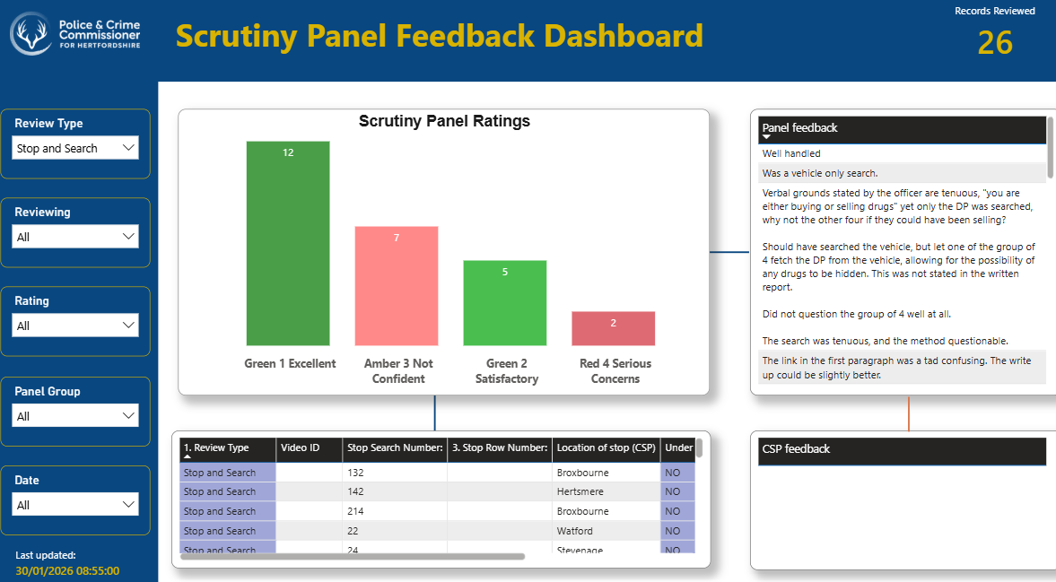
6.4 | 26 records were reviewed in total.  - Green 1 excellent – 12  - Green 2 satisfactory – 5  - Amber 3 not confident – 7  - Red 4 serious concern – 2  For the records that received a red 4 grading, one was because it was a vehicle only search, and the other because the grounds for the search were deemed tenuous. Please note that the red rating for the vehicle will not be included in the final stats.  BWV footage was shown for a firearms case. The firearms officer stopped the individual, but another officer conducted the search. The panel would like to review the BWV of the searching officer.
6.5 | A question was raised about situations where one officer explains the grounds for a search while another officer carries out the search, and which officer’s record or BWV footage should be reviewed in these cases. Some panel members noted they had encountered records reflecting this scenario and queried whether the searching officer’s record also needed to be reviewed. CR and CC will pick up further conversations on this.  In one case, fingerprints were taken by the attending officer to ascertain the identity of the individual. The panel asked CC how long fingerprints would be kept on record for. CC will feedback to the panel on this.  Group 2 also noted that the use of IC codes was used in one record, but they understood that these are not used in Hertfordshire. CC said she would send through further information on self-defined ethnicity.
8 | Any Other Business
8.1 | None recorded.
9 | Date of next meeting:  Thursday 2nd April, 10am-1pm, OPCC offices  Rosanne House, Bridge Road, Welwyn Garden City, AL8 6UB

