Hertfordshire Community Stop and Search Panel
Thursday 2nd April, 10:00-13:00
Rosanne House
Minutes
Attendance:
Demitrius Nurse (Chair)  Andy Taylor  Jerry Rudd  Bukola Enfushile  Robert Lloyd  Mohammad Islam-Ruman  Paulette Reed |  | DN  AT  JR  BE  RL  MIR  PR | Ben Platt  Tara Bullworthy  Valerie Shrimplin  Insp. Clare Cray  Supt. Dave Cooke  Sg. Helen Wise  Charlotte Rainer  Eleanor Makoni | BP  TB  VS  CC  DC  HW  CR  EM
Also present: Sg. Katie Selby, David Chesney and representatives from the Police Cadets.
1 | Welcome, Introductions and Apologies
1.1 | The Chair (DN) welcomed panel members, officers from the Constabulary, observers, and young people from the Police Cadets who were attending as observers.
1.2 | Apologies were noted from: Jeffrey Burke, Phil Millard, Jacqueline Gaffin, Eddie McCarrol, John Gillett, Jamal Pasha, Godrey Minsky, Linda Blake, and Nigel Marshal.
2 | Minutes of the Previous Meeting, Actions and Matters Arising.
2.1 | The minutes of the previous meeting held in January were agreed and the action tracker was updated.
3 | Constabulary feedback
3.1 | CC presented feedback on the case that was previously graded as a serious concern at the January meeting.  The feedback will be circulated with the minutes. Overall, the feedback indicated that the written grounds should have better reflected the intelligence used to justify the stop and search of the individual in that location.  Panel members questioned why only one individual was stopped and searched and not the other four group members. The individual was described as acting “suspiciously” without sufficient detail, which was not considered adequate grounds to search others nearby. Without evidence of an exchange or a Section 60 authority, searches of the other individuals were not justified. Overall, the panel agreed that the grounds were poorly written and highlighted the need for clearer justification.
3.2 | CC shared the ethnicity markers now used by officers to support conversations about self-defined ethnicity. The aim is to encourage officers to ask individuals how they define their own ethnicity, rather than relying on officer-defined classifications. These are nationally set co  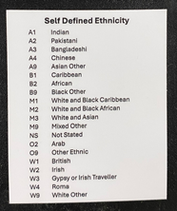
3.3 | CC introduced the new Stop and Search “Know Your Rights” cards as part of the workstream aimed at improving transparency and understanding. Officers will provide the card to individuals who are stopped, explaining their rights, how to give feedback about their treatment, and how to obtain a copy of the search record. The cards are currently being printed and have not yet been issued; however, an electronic version can be shared in the meantime. There is no legal requirement to use the cards, but their use is regarded as best practice and will be encouraged. The cards are expected to be rolled out in April, and the panel may begin considering their use as part of the scrutiny process from May onwards.
3.4 | At the previous meeting, the panel queried how long fingerprints were kept on record where needed for roadside identification.CC confirmed that these fingerprints are not stored, as they are not part of any investigation and are used solely as a screening tool.
3.5 | CC provided an update on the January action regarding searches where one officer states the grounds, and another conducts the physical search. It was confirmed that the officer who establishes the grounds is responsible for completing the search record. TuServ allows other involved officers to be listed and to view the record. The panel queried whether additional officers needed to submit separate records; CC clarified that only one record is required, as only one physical search takes place, and multiple records would result in duplication.
3.6 | CC highlighted an ongoing data issue whereby the time of stop and search records appears as midnight when transferred into TuServ. This is a known system issue and should not affect the panel’s scrutiny.
4 | Panel Feedback – Countywide
4.1 | Scrutiny activity took place between 10:20 and 12:00. An under-18 deep dive was conducted covering records from January and February. The following dashboard presents panel gradings. It was noted that the dashboard is cumulative and includes records scrutinised at the January meeting.
4.2 | As there were insufficient panel members for five subgroups, group four and group five records were not scrutinised.
 | 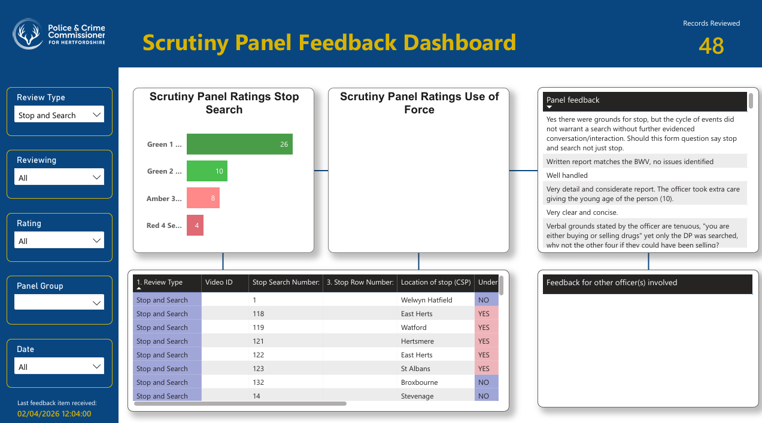
4.3 | 23 records were reviewed in total.  - Green 1 excellent – 14  - Green 2 satisfactory – 5  - Amber 3 not confident – 1  - Red 4 serious concern – 3  For the cases rated as Red, this relates to poorly written records, a lack of detail, and records being copied and pasted.
4.4 | Panel members identified examples of good practice, including calm officer demeanour, clear explanations of rights, respectful communication, and appropriate de-escalation. Concerns were also raised in some cases about insufficiently articulated grounds, missing steps in escalation from stop to search, copy-and-paste errors between group records, and inconsistencies in report quality.
4.5 | Safeguarding featured heavily in discussion, particularly in cases involving children and young people. Panel members discussed proportionality, handcuff use, references to Tasers, and language that could be perceived as threatening or escalatory. It was noted that new safeguarding guidance for under-18s is forthcoming and that future scrutiny will provide an opportunity to assess how this guidance is embedded.
4.6 | Feedback from group discussions highlighted recurring concerns around report quality, particularly where multiple individuals were searched. Panel members noted that some records failed to clearly identify who was searched or to distinguish individual grounds.
5 | Consultation on panel changes
5.1 | DC introduced a discussion on the future structure of the scrutiny panels. This included proposals for an omnicompetent panel bringing together Stop and Search and Use of Force, alongside changes to meeting frequency (bimonthly to quarterly) and diversifying panel membership.
5.2 | Panel members voiced strong concerns that such changes could dilute scrutiny and risk the process becoming a “tick-box” exercise. In particular, panel members expressed significant concern about reducing the meeting frequency to quarterly, highlighting the potential impact on panel engagement, continuity, and the overall effectiveness of scrutiny.
5.3 | Panel members emphasised that a clear vision is required for what effective scrutiny should achieve and suggested that better use could be made of data sub-groups to enable more focused and meaningful selection of records for review. It was stressed that any future changes must be co-designed, transparent, and aligned with a clearly articulated vision for independent oversight.
5.3 | In relation to next steps, a feedback survey will be circulated to panel members to gather initial views. A working group will then be established to help co-design the future format of the panel. Panel members requested clear communication and meaningful opportunities to be consulted throughout the process.
6 | Any Other Business
6.1 | DN formally recorded the panel’s thanks to Inspector Clare Cray and acknowledged her significant contribution and support, as this was her final meeting.
Date of next meeting:
Thursday 11th June, 10am-1pm
Rosanne House, Bridge Road, Welwyn Garden City, AL8 6UB

