

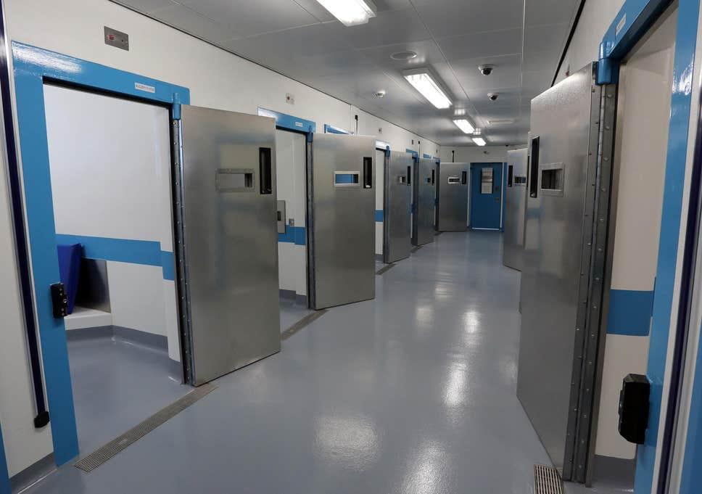

INDEPENDENT CUSTODY VISITORS SCHEME
ANNUAL REPORT
2024 – 2025



Contents
Foreword by Jonathan Ash-Edwards, Police and Crime Commissioner for Hertfordshire 3
Foreword by the Chief Inspector of Hertfordshire Constabulary’s Custody Units 4
Overview of the Scheme 5
Quality Assurance Framework 6
Key Findings (1st April 2024 to 31st March 2025) 7
Number of Visits 7
Detainee Data 8
Profile of the Independent Custody Visitors 9
Matters arising from custody visits 11
Categories of issues raised by ICVs 13
Areas of focus for the year ahead (2025/2026) 18
Recruitment 18
Data Quality 18
Quality Assurance Framework 19
Anti-Rip Clothing Scrutiny 19
ICVA 19
Appendix 1 20

Foreword by Jonathan Ash-Edwards, Police and Crime Commissioner for Hertfordshire

The Independent Custody Visiting Scheme Annual Report for 2024–2025 reflects the dedication, integrity, and commitment of our Independent Custody Visitors (ICVs), who continue to play a vital role in ensuring transparency and accountability in our custody suites in Hertfordshire.
I am grateful for the continued professionalism, commitment and compassion shown by our ICV volunteers. Their work provides essential oversight for the rights and welfare of detainees, offering reassurance to the public that our police custody practices are fair, lawful, and respectful of human dignity.
This year’s report highlights both the challenges and achievements of the scheme. Despite temporary closures of custody suites for refurbishment and the added pressure of supporting neighbouring forces, our ICVs conducted 96 visits and engaged with 694 detainees. The increase in the percentage of detainees visited, alongside a reduction in the number of issues raised, demonstrates the positive impact of ongoing improvements in custody procedures and volunteer engagement.
The scheme continues to seek to improve the diversity of ICVs with renewed efforts to recruit volunteers from under-represented parts of Hertfordshire. This is essential to maintaining public confidence and ensuring that all voices are represented in our oversight processes.
Looking ahead, we remain committed to enhancing the scheme through improved data quality, digital innovation, and the pursuit of excellence under the Independent Custody Visiting Association (ICVA) Quality Assurance Framework. The introduction of a new ICV visit booking system and the continued collaboration with ICVA are promising steps toward a more efficient and responsive scheme.
I would like to extend my sincere thanks to every ICV, past and present, for their invaluable contribution to scrutiny, accountability and high standards. I also thank the staff of the Office of the Police and Crime Commissioner and Hertfordshire Constabulary for their ongoing support of the scheme.
Together, we will continue to ensure that custody in Hertfordshire remains a place which is safe, where people are treated with dignity and custody is open to scrutiny.
Jonathan Ash-Edwards
Hertfordshire Police and Crime Commissioner


Foreword by the Chief Inspector of Hertfordshire Constabulary’s Custody Units
I am pleased to contribute to this year’s Independent Custody Visiting (ICV) Scheme Annual Report, which once again highlights the vital role our volunteers play in ensuring transparency, accountability, and the highest standards of care within our custody environments.
The past year has presented both challenges and opportunities. Temporary closures of our custody suites for essential refurbishment, alongside the additional demand from supporting neighbouring forces, tested our resilience. Despite this, the professionalism of our custody staff and the dedication of our ICVs ensured that detainee welfare remained a top priority. I am particularly proud that, even with fewer visits, the percentage of detainees seen by ICVs increased, reflecting improved engagement and operational efficiency.
The feedback from ICVs continues to be instrumental in shaping our practices. Their observations—whether highlighting areas for improvement or recognising compassionate and professional conduct—are taken seriously and acted upon. The reduction in reported issues, especially in areas such as access to medical care, is encouraging, though we acknowledge there is still work to do, particularly in strengthening healthcare provision and ensuring consistent service availability.
Looking ahead, we remain committed to working closely with the Office of the Police and Crime Commissioner and the ICVs to enhance our service.
I extend my sincere thanks to all our ICVs for their time, commitment, and integrity. Your work is a cornerstone of public confidence in our custody services, and your continued partnership is deeply valued.
Paul Mitson,
Chief Inspector,
Head of Hertfordshire Custody

Overview of the Scheme
Under the Police Reform Act 2002, all police force areas are required to have a custody visiting scheme. The scheme’s independent checks give the public reassurance that detainees are being treated fairly, that their legal rights and entitlements are given, as well as checking their welfare and dignity are being maintained. Independent Custody Visitors (ICVs) also review the custody suites for issues around cleanliness and maintenance. The scheme also provides assurances to detainees at a time when they may be feeling vulnerable or confused.
Following the introduction of Police and Crime Commissioners (PCCs) under the Police Reform and Social Responsibility Act (2011), the PCC assumed responsibility for the operation of the Independent Custody Visiting Scheme in Hertfordshire. The Office of the Police and Crime Commissioner (OPCC) manages and supports the smooth running of the scheme including the day-to-day enquiries, recruitment of the volunteers and improvements and development to the scheme.
ICVs are unpaid volunteers who live, work or study in Hertfordshire – at the end of March 2025 we had 27 ICVs compared to 29 last year. Recruitment will be a focus over the coming year to replace those who have already left and those who will be reaching the end of their tenure in the next 12 months. This recruitment drive will also make renewed efforts to attract volunteers from diverse backgrounds to better reflect the communities the scheme serves.
In ordinary times all visits are unannounced and can take place at any time, 24 hours a day, 7 days a week. The ICVs are trained to introduce themselves to detainees in custody and ask questions that ensures their treatment is fair and that they have access to their rights and entitlements. At the beginning of each visit, ICVs are told how many detainees are in custody at the suite being visited. The detainees are then introduced to the ICVs and, subject to their consent and availability a visit is undertaken.
ICVs complete a report form summarising their visit to each individual detainee. This is then forwarded to the scheme manager at the OPCC, with a hard copy retained by custody staff. Concerns raised by ICVs are reported to the Custody Inspector or escorting officer at the time of the visit and then submitted to the scheme manager for review. The scheme manager highlights any concerns with the Custody Chief Inspector via email, telephone, or during regular meetings, depending on the urgency. The ICVs can also raise general matters arising from visits at their regular half-yearly meetings with the OPCC.
The position of an ICV is an unpaid, voluntary role. All ICVs are encouraged to regularly complete an expense form to allow any costs associated with visits to be reimbursed by the Commissioner. The Commissioner also incurs other related costs for running the scheme including, but not limited to OPCC staff time, ICV training, printing, some limited catering for panel meetings, conference booking fees, and OPCC membership of the Independent Custody Visiting Association (ICVA). Over the year, training has been carried out online so no catering has been required for in-person meetings, the scheme manager attended the ICVA National Conference in November 2024 at a cost of £150+VAT plus travel and OPCC Membership of ICVA was renewed at a cost of £1750+VAT. ICV Expenses claims have totalled £1,850.
Nationally, the Independent Custody Visitor Association leads, supports and represents PCCs and police forces with regards to the Independent Custody Visiting schemes. The OPCC has developed a good relationship with ICVA and other scheme managers over several years. This has enabled the OPCC to ensure the scheme’s aims and management are effective, and that they are kept informed of legislative changes and reforms. The recent increase in the ICVA subscription fee will allow them to develop improved ICV training and create a digital reporting tool that captures information from visits.

Quality Assurance Framework
The Quality Assurance Framework (QAF) was introduced by the Independent Custody Visiting Association (ICVA) in April 2018. It enables schemes to reflect on how they comply with the Code of Practice and the legislation which underpins custody visiting. The QAF seeks to encourage schemes to celebrate areas of strength and achievement, promote custody visiting, drive performance, recognise the independent voice of volunteers, and increase sharing of good practice.
Having been presented with the silver award in November 2023, ICVA has since launched the revised standards (March 2025). Over the next year it is our aim to build on what has been achieved so far and work towards a new gold standard.

Key Findings (1st April 2024 to 31st March 2025)

Number of Visits
Over twelve-months, 12,856 detainees passed through both custody suites (6,766 through Hatfield and 6,090 through Stevenage). This compares to a total of 12,280 detainees in 2023/2024, an increase of 4.6%. This in a slight increase on the previous year and could be accounted for by the fact that during the year Hertfordshire was an overflow for the Luton custody suite which was undergoing renovation. Overall, ICVs visited 5.3% of those detainees who were booked in, an increase on the previous year (4.7%). A figure that can be attributed to a higher number of visits carried out over the year.
Figure 1 shows that in 2024/25, ICVs undertook 96 custody visits, speaking to or observing a total of 694 detainees from a possible 805 who were available for a visit. While the number of visits is down from 113 on the previous year, both custody suites were closed for refurbishment for several weeks over the summer of 2024. This prevented the usual visits from happening.
Figure 1: Breakdown of the visits for the period 1st April 2024 to 31st March 2025
Custody Suite Visited | No. of visits undertaken | No. of detained persons held | No. of detainees available to visit | No. of detained persons visited | % of detainees visited (of those available)
Hatfield | 46 | 569 | 413 | 364 | 88%
Stevenage | 50 | 557 | 392 | 330 | 84%
TOTAL | 96 | 1126 | 805 | 694 | 86%

Although the number of visits decreased, as illustrated in Figure 2, the percentage of detainees spoken to or observed increased slightly from 85% to 86%. It should be noted that the number of detainees held at the time of ICV visits was 39% higher than in the previous year. This increase is possibly due an overspill from Luton custody which underwent a refurbishment at the end of 2024/25. In addition, the work undertaken in 2023/24 to improve how custody officers introduce ICVs to detainees may also be improving the level of engagement.
Figure 2: Comparison of detainees seen between 2021/22 and 2024/25
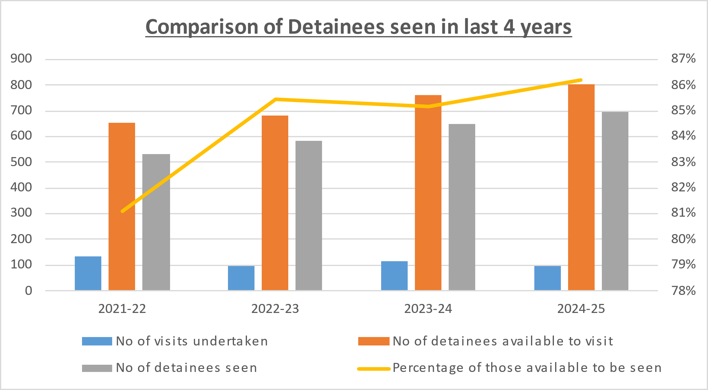
Declined Visits
Detainees who do not consent to a visit equates to 14% of the cohort (see Figure 1). This is a slight decrease on the previous figure of 15% and compares more favourably with other forces; the refusal rate elsewhere is between 7% and 16%. There are several reasons why ICVs are unable speak to detainees, including detainees being asleep, intoxicated or deemed too violent by custody staff. Detainees may also be unavailable if they are being interviewed, they may be in Court, with a health care professional or providing a DNA sample.
In the coming year we will continue monitoring refusal data and try to find ways of improving the interactions between detainees and ICVs.

Detainee Data
Figure 3 shows that the proportion of ‘Not Recorded’ self-defined ethnicity has once again decreased on the previous year and now accounts for 19% of records, down from 21%. While this is not a mandatory field on the custody record, the expectation is that staff complete this field and that future updates to the system will make this mandatory. Monthly reports are reviewed by the Custody Chief Inspector to identify non-compliance so that Inspectors can address these issues their teams directly.

Figure 3: Self-Defined Ethnicity of those passing through custody 2024-2025
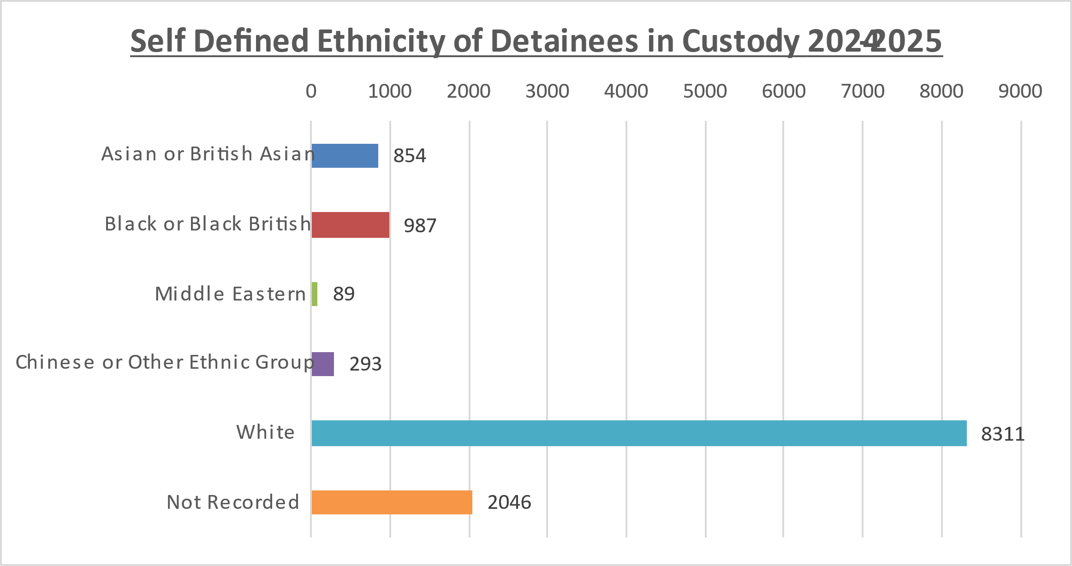

Profile of the Independent Custody Visitors
At the end of 2024/25 there were 27 ICVs supporting the scheme who live in Hertfordshire. This is a decrease of two on the previous year. While short of our target of retaining around 30-35 volunteers the level of engagement and commitment among the existing cohort of volunteers is high, which means the scheme operates well and further recruitment will be targeted over the next year.

ICVs are asked to fill in a voluntary information disclosure agreement. This year 100% declared their age and gender, and 74% disclosed their ethnicity. From the data available, 56% of volunteers are male, 44% are female, 70% are from white backgrounds and 70% are over the age of 60 years (see Figures 4 and 5). Forthcoming recruitment campaigns will focus more notably on how we engage people from all backgrounds to increase diversity among our ICVs.

Figure 4: Ethnicity profile of the Independent Custody Visitors
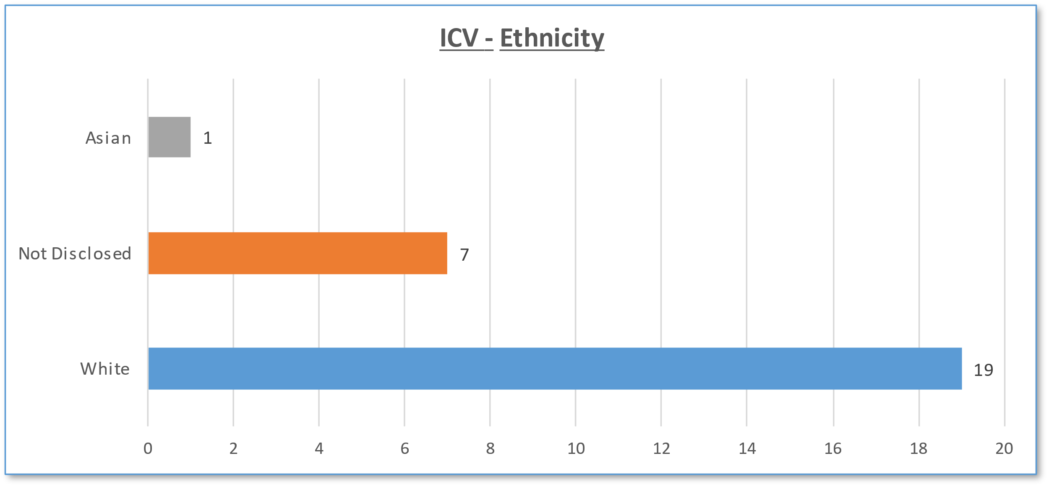

Figure 5: Age profile of the Independent Custody Visitors
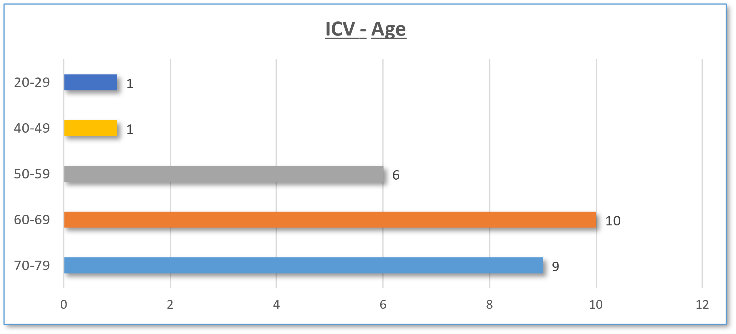

Matters arising from custody visits
ICVs have performed at least one visit to each custody suite per week, other than when these were closed for refurbishment. The visits take place over a 24-hour period which meets the minimum statutory requirement. We aim to undertake a total of three visits per week when availability permits – this has not been consistently possible in the reporting year due to volunteer capacity.
During 2024/25 of the 694 detainees visited, issues were noted from 21 detainees (3%) compared to 27 (4.2%) in the previous year. In total, 36 issues raised by detainees were reviewed and 10 raised by ICVs. Concerns raised by detainees relate to the Rights of Detainee, and more specifically access to medical help (see Figure 7).
Overall, 97% of detainees did not raise any issues regarding their welfare whilst in custody, this is compared to 96% over the previous reporting period. Given the number of reported issues is very low and ethnicity is not recorded in every instance, it is difficult to draw firm conclusions about bias relating to ethnicity. Figure 6 shows the breakdown of reported issues by ethnicity.

Figure 6: Rights of Detainee by self-defined ethnicity
 | Rights of Detainee | Vulnerable Detainees | Access to Amenities | Services Available | Cleaning | Maintenance | Food Drink Reading | Detention Issues PACE | ICV Staff Issues | Positive Feedback
White British | 13% | 3% |  |  | 3% |  |  | 1% |  | 5%
White Irish |  | 1% |  |  |  |  |  |  |  | 1%
Any Other White | 1% | 1% |  |  |  |  |  |  |  | 4%
White and Black Caribbean |  | 1% |  |  |  |  |  |  |  | 1%
White and Black African
Mixed White and Asian
Any Other Mixed | 1% |  |  |  |  |  |  |  |  | 1%
Asian/British Indian
Asian British Pakistani |  |  |  |  |  |  |  |  |  | 1%
Asian/British Bangladesh |  |  |  |  |  |  |  |  | 1%
Any Other Asian
Black/British Caribbean | 1%
Black/British African | 1%
Any Other Black | 1%
Chinese
Any Other Ethnic Group | 1%
Refused/Not stated | 1%
Not Recorded by ICV | 0% |  |  | 9% | 9% | 9% | 7% |  | 12% | 5%

Categories of issues raised by ICVs
- Rights of Detainee
Rights of the Detainee are broken down into 13 sub-categories and detailed in Figure 7.
Figure 7: Sub-categories of issues relating to the Rights of Detainee
Rights of Detainee | Number of Issues raised | % of total | Number of Valid Issues/ Number of Not Valid Issues
Access to medical help | 7 | 41% | 3/4
Phone Call | 4 | 24% | 0/4
Access to food | 2 | 12% | 1/1
Access to free legal advice | 2 | 12% | 0/2
Not given rights | 1 | 6% | 1/0
Someone informed of their location | 1 | 6% | 0/1
Privacy while receiving legal advice | 0 | 0%
Access to "Codes of Practice" | 0 | 0%
Can see written notice of rights | 0 | 0%
Access to drink | 0 | 0%
Access to interpreter/language cards | 0 | 0%
Access to complaints procedure | 0 | 0%
Contact Embassy | 0 | 0%
Total issues noted | 17

The highest reported area of concern once again is ‘access to medical help’; however, the number of issues reported is reduced from the 12 recorded last year to 7. Of the seven issues raised, it was verified that two of these were due to a delay in being seen. In two other cases the detainees had not notified custody staff of their medical needs – this information led to subsequent medical visits. The remaining three cases were due to issues in administering medication; one due to medication not being labelled which staff are unable to administer; one due to missing doses due to lack of medical cover on site; and one stating medication was needed, which the detainee didn’t have. On this occasion a medical visit was arranged and in the other cases, substitute medication was provided.
Only one person wished to make a formal complaint about the delay and again, the importance of getting medication to detainees promptly has been reiterated. In this case the delay in administering the dose could have had serious repercussions for the welfare of the detainee.
On nine visits the ICVs specifically commented on the lack of on-site healthcare provision. either at certain times of the day or for extended periods. A new provider took over the contract in April 2024 with the expectation that there would be better coverage over each 24-hour period. While there is no data showing where gaps are happening most frequently, the impression from ICVs is that coverage has improved when noted at the time of their visits. Figures show coverage rates as high as 97.3% in March 2025 but as low as 67.1% in June 2024. The average for healthcare cover over the year is 87.2% per month overall.
Gaps in healthcare coverage are still proving to be an issue although there is no time of day where coverage is consistently lacking but these issues are being raised with the provider.
Of the four issues relating to phone call, in two cases, this had been refused for operational reasons, one was refused because the detainee only wanted a private call which could not be granted. In the other case, the detainee had no contact details, but staff were attempting to make contact with a family member.
Of the issues regarding access to food, in one case the detainee claimed they had not had any food, a check of the custody record showed they had been given food. In the other case, the detainee claimed they had asked for a meal which had not been provided. A check of the custody record was inconclusive about whether this had been requested, and any action taken.
It should be noted that the issue of low stocks of sandwiches was sometimes reported by ICVs however there was always a supply of ready meals. The sandwich option is an alternative to ready meals but is not guaranteed. There were no instances where there were no meal options at all.

- ICV Staff Issues
This was the second highest reported category with ten issues highlighted. This is a general category for ICVs to highlight issues they witness or encounter in the custody suite or any general issues that do not fit into other categories. Four of these relate to delays in ICVs gaining entry to the suite or starting the visit. This was either due to the suite being exceptionally busy and short staffed, or other incidents requiring officers’ attention that could pose a risk to the ICVs.

Four issues were directly related to lack of blankets with clothing having to be used in lieu of adequate supplies. This issue has subsequently been taken up by senior custody officers and a new contract is being put in place to address the irregular supply issues.

One issue raised by ICVs involved them being challenged by a Sergeant upon letting themselves into an area near a custody suite. The ICV was questioned as to whether they should be there. The ICVs are vetted, they work in pairs and have been granted access to police stations so that when safe to do so, they are able to enter a custody suite directly. The officer concerned was identified and while it was acknowledged he was concerned for the safety of both the station and the ICVs, it was clarified what right of access they have.

The final issue related to ICVs not passing on a message from a detainee to the escorting officer. The ICVs believed the officer would have heard what was said so did not follow the correct procedure in making sure the officer was aware. The scheme manager spoke to both ICVs and clarified what was expected in this situation.

At present 69% of prisoners at Hatfield and 70% at Stevenage wait less than 30 minutes to be booked in at custody suites.

- Cleanliness & Maintenance
Cleanliness and maintenance issues were noted on a total of ten occasions. Issues related to cells that needed cleaning, an unclean microwave in the kitchen and dirty air-conditioning units. CCTV issues were mentioned on at least five occasions, and it was noted that the systems were due to be replaced and upgraded. This upgrade is now complete with ICVs and staff commenting on how good the new system is.

All issues had been reported by custody staff and were waiting to be addressed. Overall, the ICVs regularly comment on how clean and well-kept all areas of custody are, and the issues reported are rare.

- Services Available
While on-site medical cover has improved, on seven occasions it was specifically mentioned that cover was not available when needed. This is something that will continue to be monitored as it is understood that the contractor is trying to get more staff in place to cover the gaps.

- Vulnerable Detainees
In the reporting year, the ICVs identified two issues of concern relating to juveniles who were kept in overnight. In both cases there had been delays in appointing an Appropriate Adult. This was being followed up regularly by custody officers however, social services were advising that no-one was available, and no family member could be contacted.

There are robust processes in place that aim to prevent overnight detention for vulnerable juveniles which were positively commented upon during the most recent HMICFRS inspection10. In both these cases, neither young person could be released home. The ICVs were satisfied that the assessments were reasonable, and both detainees commented that they had been well looked after.

One person was noted as being held under Section 136 of the Mental Health Act 1983.

- Food & Drink
Four issues were noted relating to food and drink. Four related to the lack of sandwiches and intermittent supplies. While there are always plenty of other food options, such as microwave meals, sandwiches are stocked as an alternative. While stocks are monitored and provided there are other options, low supplies are not considered a major issue.

One issue related to the lack of Kosher food. While there was Hallal options, staff could not offer a Kosher option. To ensure that the detainee had something to eat, a staff member went and purchased some items.

No issues were noted by the ICVs under any of the other reporting categories during the 2024-25 reporting period.

- Summary

It is positive to see the number of issues reported by ICVs have not increased. Although some of the themes around healthcare provision are not fully resolved with a change of contractor, the issues of gaps in coverage are being raised with the provider and we will expect to see an improvement over the first half of the next reporting year. Overall, the observations made by ICVs continue to demonstrate that the Constabulary is maintaining the welfare, dignity and needs of detainees. These standards have also been maintained during a period when custody suites have been refurbished and when detainees from Bedfordshire were being brought to Hertfordshire.

- Positive Feedback
ICVs recorded several positive comments by detainees regarding their welfare in custody. Of the 15 noteworthy positive comments, 11 were from detainees and 4 from the ICVs. All detainees chose to comment specifically about their welfare saying they had been well treated and that their dignity had been maintained. Comments such as; “very well looked after”, “everyone polite and reasonable”, “they’ve been tip-top, brilliant”, “10 out of 10” are of note.
Once again ICVs also noted that police staff were helpful and professional when dealing with detainees and themselves. This is commented on during most visits. On one specific occasion the ICVs noted a particularly compassionate interaction where a detainee had felt claustrophobic. The Perspex screen on the cell door was left open so the detainee could see the corridor and feel less enclosed.

Areas of focus for the year ahead (2025/2026)

Recruitment
Recruitment will continue with a focus on targeting a wider age and ethnic demographic, particularly as some volunteers will reach the end of their three-year tenure period. With new outreach and social media capacity within the OPCC we will seek to utilise these skills to promote and communicate more effectively.
Additionally, we will continue to use the GoVolHerts online volunteering portal to reach out to the community and take part in their volunteering activities. Work has been undertaken to explore other established online volunteering portals which have an extensive base of potential volunteers.
IT Systems
The Constabulary’s intelligence and case management system, Athena, provides ICVs with a snapshot of the detainees in custody when they arrive to undertake their visit. There are still occasional outages causing timeliness issues with obtaining the data, resulting in delays for ICVs. This continues to be monitored as updates are made to the system.
The OPCC is reviewing how other forces use electronic reporting for their ICVs. ICVA will also be developing a standardised system which may prove more suitable and cost effective than a bespoke approach. Our aim is to move to electronic reporting so that visit data is captured consistently, and so staff do not need to scan and email the forms, which also creates a more secure system for processing and analysing data.
The OPCC has also rolled out a new system for the ICVs to book their visits. This started to be trialled at the end of the reporting period and has so far proven successful. This creates greater flexibility for ICVs to coordinate their unannounced visit times.

Data Quality
The Constabulary continue to review the data they record about detainees. Whilst the recording of self-defined ethnicity has improved in the last year, with fewer instances when it is not recorded, custody staff are being reminded to always record this information or mark it as “not stated”. In parallel, the OPCC will continue to monitor and raise issues with Chief Officers to improve systems and data capture.

Quality Assurance Framework
At the end of the year ICVA announced the next round of its QAF (Quality Assurance Framework) which will run until April 2026. The work previously carried out to achieve the silver award has identified areas to improve and consolidate. This largely relates to increasing the level of diversity among volunteers and improving our engagement with volunteers and the community. Working towards improvement has started and will lay the groundwork for a potential gold standard in this new assessment period.

Anti-Rip Clothing Scrutiny
In April 2023, a new scrutiny panel was established to review the use of anti-rip or safety clothing in custody – this was in response to recommendations in the most recent HMICFRS Inspection of Custody. The panel is made up of ICVs and representatives from the Constabulary who continue to meet on an regular basis to review incidents and ensure the use of the clothing is justified and proportionate.
Using feedback from these reviews the Constabulary has introduced changes to reduce the use of this clothing.
Due to some ICVs stepping down we will be looking to recruit and train others to join this panel and continue with the scrutiny it provides.

ICVA
ICVA monitor issues raised by scheme managers across the country to review and assess national trends and cascade details of legislative changes and reforms. The OPCC will continue monitoring any findings to inform the scheme’s ongoing development.

Appendix 1
The term vulnerable applies to any person who, because of a mental health condition or mental disorder:

(i) may have difficulty understanding or communicating effectively about the full implications for them of any procedures and processes connected with:
• their arrest and detention; or (as the case may be)
• their voluntary attendance at a police station or their presence elsewhere, for the purpose of a voluntary interview; and
• the exercise of their rights and entitlements.

(ii) does not appear to understand the significance of what they are told, of questions they are asked or of their replies

(iii) appears to be particularly prone to:
• becoming confused and unclear about their position;
• providing unreliable, misleading or incriminating information without knowing
or wishing to do so;
• accepting or acting on suggestions from others without consciously knowing
or wishing to do so; or
• readily agreeing to suggestions or proposals without any protest or question.

Interested in becoming an Independent Custody Visitor?
If you are interested in becoming an Independent Custody Visitor please contact:
Independent Custody Visiting Scheme Administrator
Office of the Police and Crime Commissioner for Hertfordshire
13 Vaughan Road
Harpenden
AL5 4GZ

Telephone: 01707 806100
Email: pccadmin@herts-pcc.gov.uk

For more information regarding the role of ICVs and that of the Police and Crime Commissioner for Hertfordshire, please visit www.hertscommissioner.org

For more information on the role of the Independent Custody Visiting Association (ICVA), please visit: www.icva.org.uk

We welcome applications from anyone who lives in Hertfordshire. The OPCC is particularly interested to hear from younger people and those from ethnic minority backgrounds.

An extensive list of these legal rights are provided under the section Rights of Detainees
Home Page of ICVA (The Independent Custody Visitors Association)
Not all persons who are brought to custody are booked as the Custody Sergeant must determine whether the weight of evidence is sufficient or whether there is a case for an alternative intervention. For example, a detainee may require a mental health referral, or when a juvenile risks being detained overnight which would be a breach of policy. In the latter situation, alternative provisions and accommodation would be sought.
Taken from annual reports and direct enquiries with other forces.
According to the Office for National Statistics 2021 population denominators, Hertfordshire’s population demographics shows ethnicity as: White 81.8%, Asian/Asian British 8.6%, Black/ African/ Caribbean/ Black British 3.7%, Mixed multiple ethnic group 3.8%, and other 2.1%. This information can be found at: https://www.nomisweb.co.uk/sources/census_2021/report?compare=E10000015#section_5
According to the Office for National Statistics 2021 Census the comparable age range in Hertfordshire was represented by 11% aged 20-29, 21% aged 30-44, 21% aged 45-59, 6% aged 60-64, 9% aged 65-74 and 6% aged 75-84.
More than one issue may have been reported by each detainee or may have been expressed by an ICV and exclude the positive comments
For a definition of vulnerability, see Appendix 1.
HMICFRS Report on an Unannounced Inspection Visit to Police Custody Suites in Hertfordshire June 2022
Police and Criminal Evidence Act 1984 (PACE) Code C – Revised July 2018 section 1.13(d)

